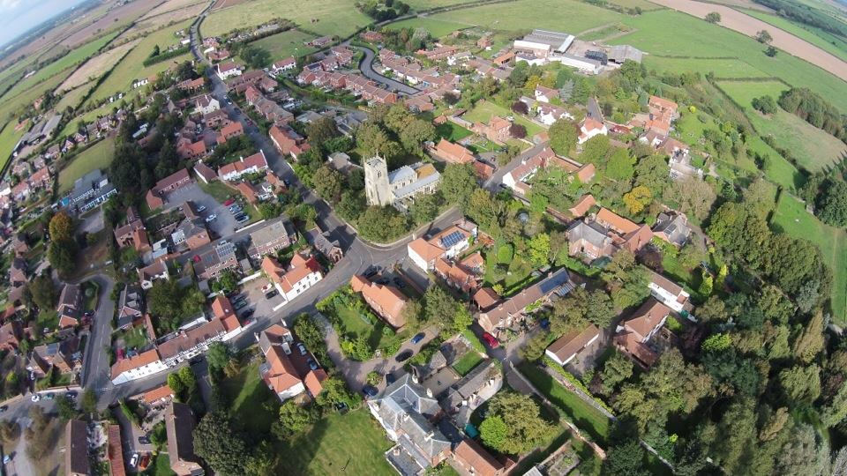
Updates to the Misson Parish Neighbourhood Plan
Saturday 21st October 12 -3:00pm at Misson Community Centre

Misson Neighbourhood Plan is being updated.
Please come along to view and have your say on the Plan and updated Policies

You will be able to meet members of the Steering Group and Bassetlaw District Council who will answer any queries and collect your thoughts on the update

